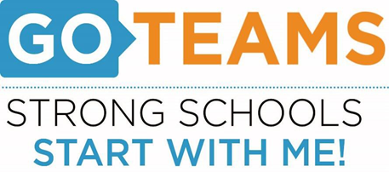

**John Wesley Dobbs**

**MEETING NOTICE**

|  |  |  |  |
| --- | --- | --- | --- |
| **Date** | **Time** | **Link** | **Location**  *(if hybrid)* |
| September 6, 2023 | 4:00pm – 5:00pm | [**https://atlantapublicschools-us.zoom.us/j/86844117045?pwd=bWxoZ0FQNktIVndtWXY2Mm4yVEtTdz09**](https://atlantapublicschools-us.zoom.us/j/86844117045?pwd=bWxoZ0FQNktIVndtWXY2Mm4yVEtTdz09)    **Meeting ID: 868 4411 7045**  **Passcode: GoTeam**  **Youtube: Dobbs Elementary**  **@dobbselementaryschool8427** | Via  Zoom |

**Notice Prepared By:** Sonja Yarbrough **Date Posted: 8/23/23 .**

**Meeting Agenda**

(*agenda may be amended*)

*This meeting will not allow for Public Comment*

1. **Action Items** 
   1. Approval of Agenda
   2. Fill Vacant Positions
   3. Fill Open Community Member Seat
   4. Fill Open Swing Seat
   5. *For High Schools*: Appoint Student Representatives
   6. Approval of Previous Minutes
   7. Election of Officers and Representatives
      1. Chair
      2. Vice-Chair
      3. Secretary
      4. Cluster Representative
   8. Review and Approve Public Comment Protocol
   9. Set GO Team Meeting Calendar
   10. Review, Confirm/Update, and Adopt GO Team Meeting Norms
2. **Discussion Items** 
   1. Discussion Item: Data Review
3. **Information Items** 
   1. Principal’s Update: Pancakes with Principal
   2. Information Item: HMH Intervention/Enrichment
4. **Announcement**
   1. 2023 GO Team G3 Summit – Saturday, September 23
   2. New GO Team Member Training and Orientation
   3. Grandparents Day – September 11
   4. Academic Tailgate – September 28
   5. Fall Festival – Thursday, October 26
5. **Public Comment**
6. **Adjournment**